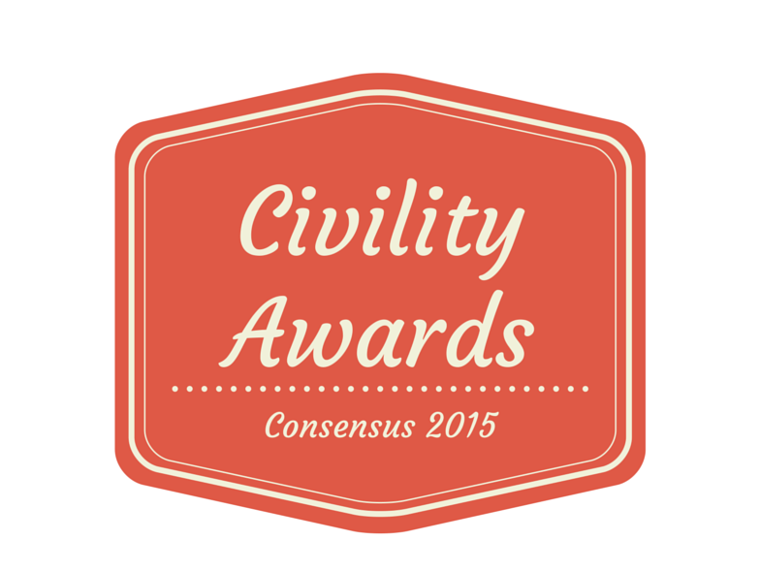
The Criteria
The Consensus Civility Award highlights people who have worked across differences to solve problems. Consensus is a nonprofit organization that engages the public in difficult public policy decisions. Our research shows that whether this happens in a civil manner depends on the people, the process, and how the problem is addressed.

Our criteria include:
- People
  - Respect. Exhibits respect for others and their viewpoints, even when they disagree.
  - Integrity. Builds and maintains trust, and fosters a sense of shared responsibility.
- Process
  - Engagement. Motivates others to participate and engage in public life.
  - Inclusiveness. Creates an open, welcoming and participatory environment.
- Problem
  - Objectivity. Works from a foundation of facts when making decisions.
  - Common ground. Works to remove the “us against them” barrier in addressing problems, and seeks common ground.

To see a list of previous Civility Award winners please visit http://www.consensuskc.org/civilityproject/

Please complete this form and then write the story of your nominee in up to 800 words. The nominee can be a person, organization or event in the Kansas City metropolitan area. We are not judging on writing ability, but we do need to know why the nominee meets our criteria. Then, please put the completed nomination form and up to three pages of attachments in one Word or PDF file and email to jenwilding@consensuskc.org. If you don’t have access to the internet, please mail the nomination form and attachments to Consensus at PO Box 10252, Kansas City, MO 64171. The deadline is September 10, 2015.
- If selected, we will need the nominee to send us a photo and bio.

2015 Consensus Civility Award Nomination Form

Name of the nominee:

Please tell us about the person who is submitting this nomination form
Your name:
Your email address:
Your phone number:
Your mailing address:
Check the ONE category for which this nominee should be considered:
Organizational
___ Government
___ For-profit
___ Not-for-profit
Individual
___ Young adult (24 or under)
___ Adult (25+)
___ Lifetime achievement (65+)
Event, activity or campaign
___ Event, activity or campaign

Please provide the contact information for the individual, organization or event you are nominating:
Name:
Email address:
Mailing address:
Phone number:
Website URL:

Does this person or group know that you are submitting the nomination?
___ Yes
___ No

Please tell us the nominee’s story
In 800 words or less, tell us the story of this nominee and why the nominee meets the criteria above.
- Do your best, please, to make a direct and clear connection between the criteria and nominee. Doing this focuses the essay on civility and keeps the board from having to guess why the nominee is the perfect Civility Award recipient.

Thank you for contributing your nomination for the Consensus Civility Awards!
The board will make its decision in October and will be in touch to let you know the result.

